COMPUTATIONAL CHEMISTRY PROJECT-1

ASSIGNMENT ON AVOGADRO.

STRUCTURE 1:

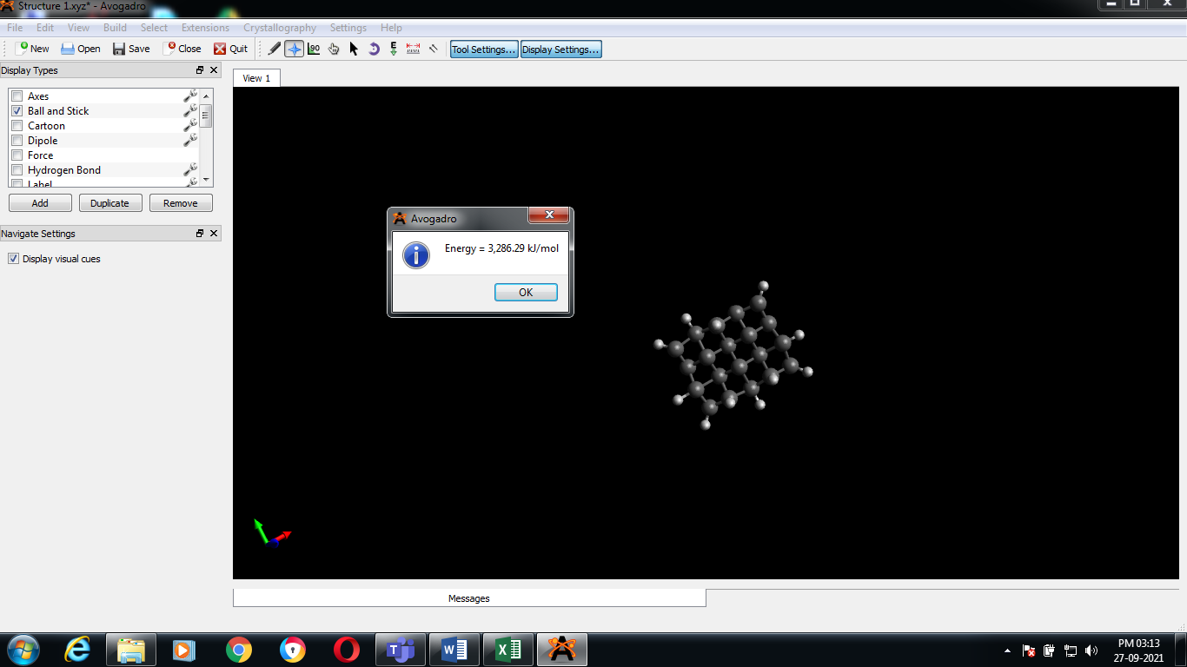

STRUCTURE 2:

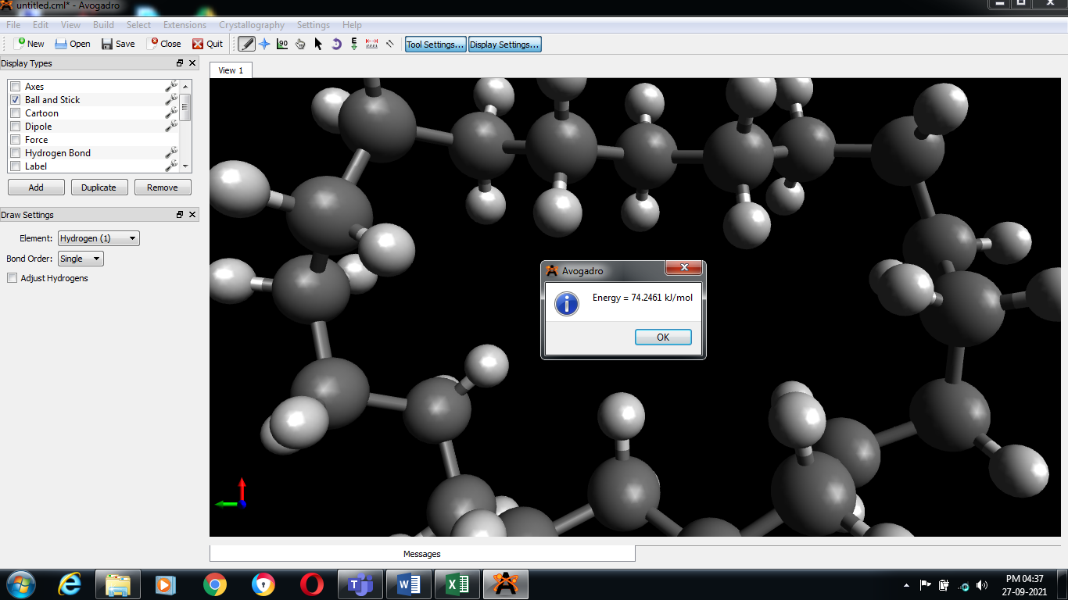

STRUCTURE 3:

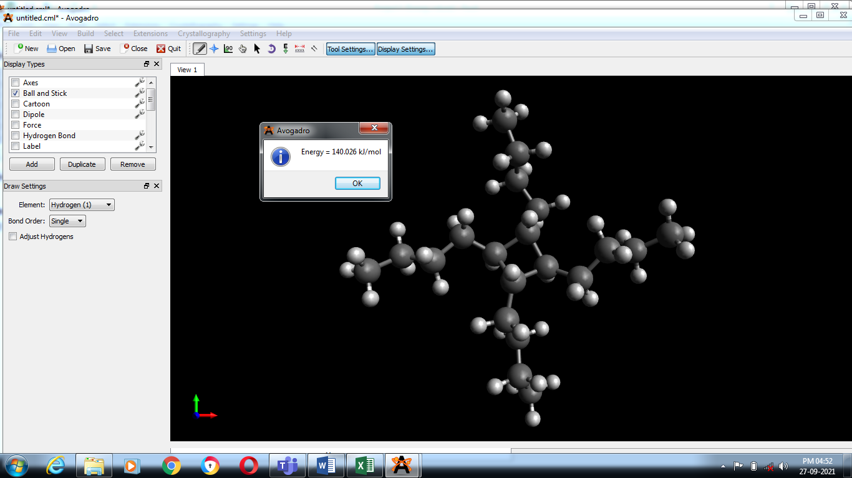

Structure 4:

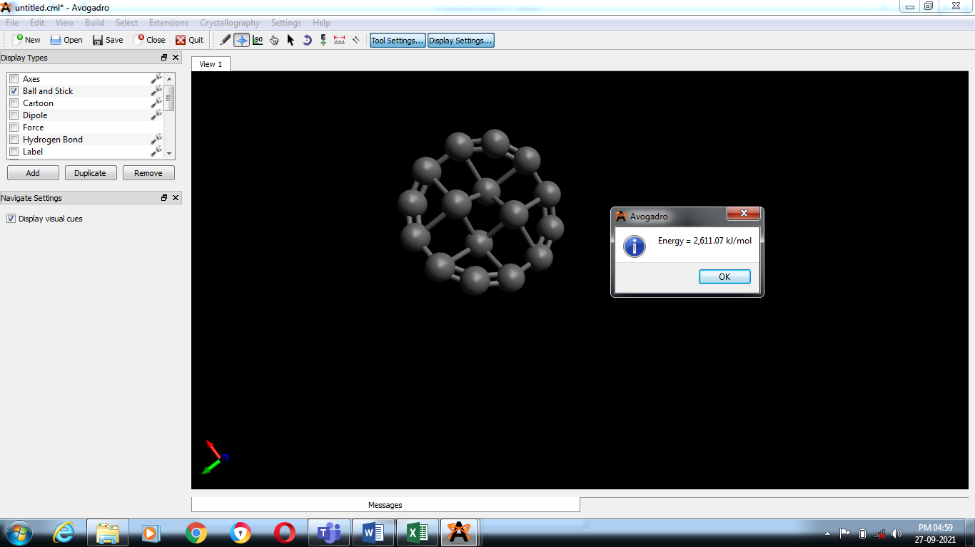

STRUCTURE 5:

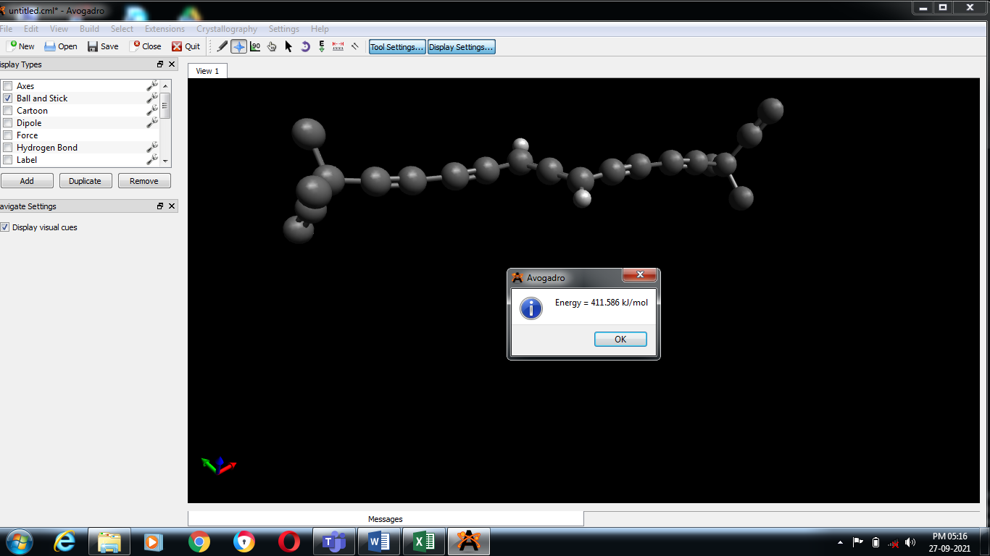

RESULT:

*Thus from the above graph, we can conclude that the structure which have more number of hydrogen atoms shows less energy and the structure which have less number of hydrogen atoms shows more energy.*

PROJECT BY:

**M. DHANUSH RAJ (21BAI10111).**

